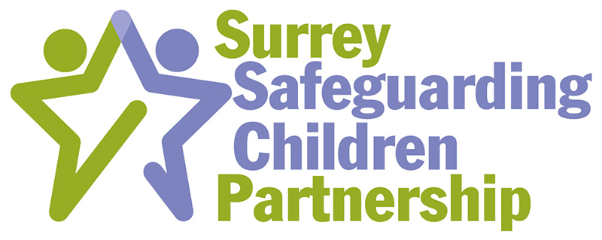

NOTIFICATION OF ALLEGATION AGAINST A PROFESSIONAL

- Do ensure that urgent medical treatment is sought if required, and that the child is supported.
- Please record information and facts given to you as soon as possible.
- Please do not attempt to obtain written statements from the child or young person concerned or ask leading questions.
- Do not discuss or inform the member of staff concerned that this referral is being made unless advised to by HR or one of the Local Authority Designated Officers.

- It is not your duty to investigate the allegation as this may lead to evidence being lost/contaminated or may even put the child, or others, at risk.

- This form is designed for both professionals, families and members of the public. Please state the allegation/safeguarding incident in the description section and the LADO will contact you if more is required.

NAME OF ORGANISATION:

ADDRESS OF ORGANISATION:
NAME & DESIGNATION
OF REFERRER:
TELEPHONE & EMAIL:
DATE CONCERN CAME
TO ATTENTION:
DATE OF REFERRAL:

DETAILS OF CHILD (PLEASE COMPLETE A SEPARATE FORM FOR EACH CHILD)
Name:
Date of Birth:
Ethnic Group:
Address:
Postcode
Is the Child known to Children’s Social Care if Yes give details including name of social worker:
Any Special Needs:
Name of parents/carers: address if different from above including dates of birth if known:
Contact Number:
Name(s) and dates of birth of Sibling(s):

DETAILS OF MEMBER OF STAFF
Name:
Date of Birth:
Ethnicity:
Address:
Telephone Number:
Position held in Organisation:
Details of employer if different from above:
Dates of Employment:
Date of last DBS check:
Other known work with children, ie scouts, church, youth work (paid/voluntary):
Details of any Previous Concerns:
WITNESSES
1. | Name:
 | Role:
 | Contact Details:
2. | Name:
 | Role:
 | Contact Details:
3. | Name:
 | Role:
 | Contact Details:
DESCRIPTION OF CIRCUMSTANCES AND CONTEXT OF THE ALLEGATION/INCIDENT/ CONCERN
Date & Time of Incident:
Place of Incident:
Details and context of the incident: (START BY STATING THE EXACT ALLEGATION AND DO NOT COPY & PASTE EMAILS/DISCUSSIONS)

Details of any action taken by referring agency to safeguard the child/ren. ie suspension, medical attention:

To report an allegation against a professional please contact the Local Authority Designated Officer (LADO)
Please send completed forms to:
LADO@surreycc.gov.uk
The partnership procedures for managing allegations against professionals who work with children can be found at https://surreyscb.procedures.org.uk/

The following section to be completed by the LADO

ADVICE GIVEN BY THE LADO:

ACTION TAKEN BY THE LADO:

NAME:
DATE:

