
Safeguarding Newsletter
Surrey Wide ICBs Safeguarding Team
August 2025

Links to other newsletters:
Surrey Safeguarding Adults Board Newsletter Summer 2025/26 | Surrey Safeguarding Children Partnership August 25 | Community Safety Bulletin August 2025

Articles this month:
Click the links below to navigate to articles.  - Domestic Abuse & VAWG Bulletin – August Incl. UK Emergency Alert  - Published SARs – Roy & Bernard  - SSCP 2024/2025 Annual Report | - Surrey Independent Visitor Service - recruitment flyer  - Safeguarding Adults Week 2025 - 17-21 November 2025  - Home Office - Standardised LA safeguarding referral forms

Domestic Abuse & VAWG Bulletin – August Incl. UK Emergency Alert

UK Emergency Alert Test – Domestic Abuse Safety Advice for Frontline Staff
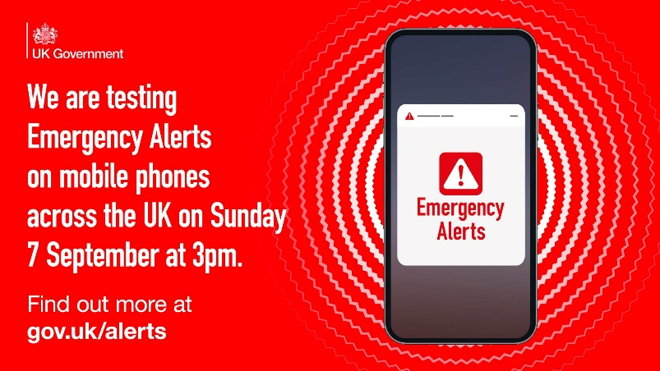
On Sunday 7 September 2025 at 3pm, the UK Government will issue a nationwide Emergency Alert test. All compatible mobile phones will:
- Emit a loud siren (even if on silent)
- Display a warning message
- Sound for around 10 seconds
Survivors of domestic abuse who use a hidden or secondary phone for safety may have that device exposed by the alert, putting them at risk.
All professionals working in health, education, housing, social care, policing, and the voluntary sector should:
- Inform clients: Advise survivors to turn off or use airplane mode on hidden phones before 3pm on 7 Sept
- Update safety plans to reflect the upcoming alert
- Share resources with teams and service users
For further advice: Emergency Alerts Test – Important Advice for Survivors and Professionals | Healthy Surrey

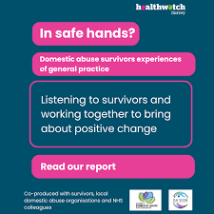
New Report Highlights Opportunities for GP Practices to Better Support DA Survivors
Healthwatch Surrey’s latest report - In Safe Hands? Domestic Abuse Survivors’ Experiences of General practice July 2025 - shares valuable insights into how survivors of domestic abuse experience general practice in Surrey and where services can improve.
By identifying the barriers to disclosure and support, the report gives professionals a clear opportunity to strengthen referral pathways, build confidence, and ensure survivors feel safe, seen and supported.
You can read the full report here: In safe hands - Domestic abuse survivors experiences of general practice - July 2025 - Healthwatch Surrey


Firearms Licensing Guidance Strengthened to Protect the Public
The Home Office has updated its guidance on firearms licensing, requiring police to take stronger steps when assessing applications. Officers must now speak with partners or household members to identify signs of domestic abuse or other concerns that could indicate someone is unfit to hold a licence. The revised rules also require additional checks to ensure those with a history of violence or abuse are not granted access to firearms.
Firearms licensing guidance strengthened to protect the public - GOV.UK

Improved Office of National Statistics Survey Methodology
From April 2025, the Crime Survey for England and Wales (CSEW) now uses enhanced questions that align with the Domestic Abuse Act 2021, covering broader forms of abuse such as health-related abuse and economic abuse. Early estimates for the year ending March 2024 suggest:
- 8.0% of adults (3.9 million people) experienced domestic abuse in the past year
- Breakdown by gender: 9.5% of women, 6.5% of men
- Lifetime prevalence: 1 in 4 adults since age 16 (26.1%)
Read the full update here: Redevelopment of domestic abuse statistics - Office for National Statistics

Useful Links:
- Domestic Abuse Training | Healthy Surrey
- How to get help | Healthy Surrey
- Anti Victim Blaming Guidance | Healthy Surrey
- Surrey Gold Standard Coercive and Controlling Behaviour Framework | Healthy Surrey
- Worried about your own or someone else's abusive behaviour? | Healthy Surrey
Published SARs
Roy
Roy died in August 2020 of Bronchopneumonia, at the start of the Covid-19 pandemic. This SAR looks at the following learning themes:
- The impact of the Covid-19 pandemic and subsequent restrictions.
- Multi-Agency working, co-ordination, information sharing and use of language – The Interaction between Services.
- Dementia Awareness.
- Working with Family Members with caring responsibilities.
- Engagement.
- Mental Capacity and Best Interests decisions.
Publication Statement
Learning Summary

Bernard – In relation to concerns of an incident of patient-on-patient attack at a nursing home.
‘Bernard’ a resident at a care home with dementia and a recorded history of violence and aggression towards residents and staff, at the care home.
Publication Statement
Learning Summary
Please note that this is a historic case.
SSCP 2024/2025 Annual Report
The SSCP Annual Report has now been published on the SSCP website and can be found here:
Surrey Safeguarding Children Partnership Annual Report 2024-2025
Surrey Independent Visitor Service - Recruitment Flyer
Please see the below flyer for circulation for anyone who might be interested in becoming an Independent Visitor to Looked after Children in Surrey.
Safeguarding Adults Week 2025 - 17-21 November 2025 * Your help is wanted!
The SSAB will be focusing its efforts during Safeguarding Adults Weeks on webinars and learning sessions. To plan for these sessions, we are keen to invite you to join us in agreeing the sessions we wish to hold, inviting speakers / subject specialist and would welcome your support in a task and finish group, with the first one to take place mid-September.
Safeguarding Adults Week is a time for organisations to come together to raise awareness of important safeguarding issues.
We believe that working in partnerships allows us to share our knowledge of safeguarding, learn from others and ultimately create safer cultures.
During Safeguarding Adults Week 2025, we’ll be collaborating with our partners to explore a different safeguarding theme each day.
Prevention: Act Before Abuse
Safeguarding Adults Week 2025 is all about prevention.
Usually, when people talk about “safeguarding”, they are talking about the policies and procedures we might put into place to respond to concerns of abuse, or to minimise the risk of a person being harmed or abused again. They are also talking about the lessons we might learn from past cases of abuse.
It’s time to change the conversation.
It’s important to learn the right lessons when things go wrong. But it is much better to prevent abuse from occurring in the first place than it is to respond to instances of harm, neglect, and isolation.
Throughout the week, we’re encouraging people to take a closer look at their approach to prevention. We want individuals and organisations to ensure that prevention is embedded in their policies and procedures.
As well as discussing some key safeguarding topics, we will also be sharing stories of instances where early intervention has helped to avoid the crisis point.
We need the courage and the confidence to act on our instincts, and to speak up when something feels wrong. And we need to build resilient communities in which people know their rights and responsibilities and understand what to do the moment they have concerns.
Themes for each day & Resources
Please respond to surreysafeguarding.adultsboard@surreycc.gov.uk to advise of your agency rep, no later than COP Friday 29 August 2025 (which will enable us enough time to arrange a meeting)
Home Office - Standardised LA safeguarding referral forms
Strategic Migration Partnerships (SMPs) across the UK have been asked to share with local authorities the attached standardised forms for referring safeguarding cases to the Home Office.
These forms should be returned to AsylumSafeguarding@homeoffice.gov.uk
The Home Office is keen to gather feedback as well as see this implemented.
Training opportunities:
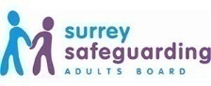
Surrey Safeguarding Adults Board Training Programme
The SSAB are pleased to provide hour long webinars on a wide range of topics.
Webinars can be accessed here and include for 2025:
- Understanding Self-Neglect
- Learning about the Changing Futures Programme in relation to adult safeguarding
- Hate Crime in Surrey
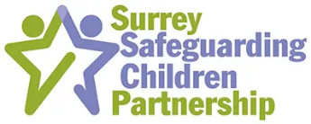
Surrey Safeguarding Children Partnership - Adolescent Safeguarding Training
The SSCP are pleased to announce the launch of a new training programme aimed at supporting frontline professionals in identifying children's needs, providing assistance, and ensuring their protection.
This training is being led by experts in social work, policing, mental health, lived experience, youth justice, and community safeguarding, and represents a significant shift in our approach to working with adolescents, their families, and communities as partners.
You can find more information and book your place for upcoming training events on our website Training - Surrey Safeguarding Children Partnership
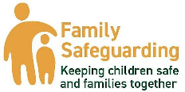
Training: Improving Strategy Meetings
8th October 9.30am to 1.00pm - Guildford Nursery School and family Centre, Hazel Avenue,
Guildford GU1 1NR (no parking before 9.30am)
13th November 9.30-1.00pm – Woodhatch 11 Cockshot Hill, Reigate, RH2 8EF

As a result of Learning from several Child Safeguarding Practice Reviews, colleagues from Surrey Children’s Services, Police and Health invite you to attend a morning’s ‘in person’ training on ‘Improving Strategy Meetings’ for better outcomes for children
Improving Strategy Meetings Tickets, Multiple Dates | Eventbrite
Surrey Wide ICBs Safeguarding Team Primary Care Level 3 Webinars
Webinars can be downloaded from https://www.surreytraininghub.co.uk/Webinars/category/safeguarding-1
please email: syheartlandsicb.surrey.safeguarding@nhs.net for the password.
- Accelerated Record Access  - Catch 22 - Surrey Young People's Substance Misuse  - Clinical Record Keeping in Domestic Abuse  - County Lines & Child Criminal Exploitation  - Dental Neglect & Vulnerabilities  - Health needs of Looked after Children including unaccompanied asylum-seeking children  - High risk Domestic Abuse & MARAC processes in Surrey  - Introductory Level 3 training for staff new to Surrey as well as GP trainees  - Learning from case reviews | - Learning from 2023 GP Safeguarding Assurance Audit  - Learning from Surrey Domestic Abuse related deaths June 2024  - LeDeR learning from the lives & deaths: Reviews of people with learning disabilities  - Level 3 Safeguarding children & adults update for General Practice: September 2023, Session 1  - Level 3 Safeguarding children & adults update for General Practice: March 2024, Session 2  - Safeguarding Supervision  - Shooting Star Children’s Hospice  - RCGP Safeguarding Standards and Toolkit Webinar
Professional Curiosity Work & Training
Re-envisaging Professional Curiosity & Challenge - Surrey Safeguarding Children Partnership (surreyscp.org.uk)

Contact Details for the Surrey Wide ICBs Safeguarding Children, Adults, Looked After Children and Child Death Review Professionals:
To contact any of the team please email: syheartlandsicb.surrey.safeguarding@nhs.net
Audrey Scott-Ryan  Associate Director Safeguarding | Lisa Parry  Safeguarding Team Business Manager | Caroline Holmes  Deputy Safeguarding Team Business Manager
Tania Steeples  Safeguarding Team Business Support Officer | Linda Cunningham / Rachael Redwood / India Sholeh  Designated Nurse Looked after Children | Dr Sharon Kefford  Designated Doctor for Looked after Children
Tara Hyde  Looked After Children and Safeguarding Children Business Support | Dr Kate Brocklesby  Designated Doctor Safeguarding Children | Tracey Bogalski & Eileen White  Designated Nurse for Safeguarding Children
Julie Wadham  Safeguarding Transition Advisor | Dr Tara Jones  Designated GP Safeguarding Adults and Children | Helen Milton & Rebecca Eells  Designated Nurse Safeguarding Adults
Dr Jamie Carter  Designated Doctor for Child Death Review | Noreen Gurner-Smith  Designated Nurse for Child Death Reviews | Suzanne Huddy  Named Nurse for Child Death Review
Natalie Price / Anna Chai / Clare Kemp  Specialist Nurse Child Death Review | Emily Welch  Child Death Review Co-ordinator | Anna Miles  Deputy Child Death Review Co-ordinator
Nicola Mundy
Child Wellbeing Professional and Lead for Learning from Child Deaths


