
Safeguarding Newsletter
Surrey Wide ICBs Safeguarding Team
October 2025

Links to other newsletters:
Surrey Safeguarding Adults Board Newsletter Autumn 2025/26 | Surrey Safeguarding Children Partnership October 25 | Child Safeguarding Practice Review Panel Newsletter

Articles this month:
Click the links below to navigate to articles.  - JSNA Chapter Published: Sexual and Reproductive Health  - Thematic SARS published | - Healthcare Learning from Case Reviews  - Stop, Look, Care Video  - Surrey Domestic Abuse & VAWG – 16 days Events & More

JSNA Chapter Published: Sexual and Reproductive Health
A new Joint Strategic Needs Assessment (JSNA) chapter on Sexual and Reproductive Health in Surrey has recently been published. This chapter was developed with the support of partners, including health, local authorities and voluntary and community sector. Feedback was also gathered through surveys and focus groups to better understand residents’ experiences and views on sexual health services.
This JSNA chapter aims to provide a picture of sexual health needs across the life course, including who is at risk of higher sexual health needs, and details of sexually transmitted infections and reproductive health needs. It provides an overview of the evidence, and the sexual health services and systems we have in Surrey. It includes feedback from stakeholders and residents about sexual health services which provide valuable insights.
The chapter highlights recommendations for action to improve outcomes for individuals, families and communities. The chapter is informed by an interactive Tableau dashboard, available to view within the chapter.
The full chapter can be found here: Sexual Health JSNA | Surrey-i
Please do contact jsnafeedback@surreycc.gov.uk with any comments, queries, or feedback on this.
Thematic SARS published

‘Agatha’ and ‘Nick’ (September 2025) – In relation to unexpected deaths.
This thematic SAR looks at suicide prevention, following the deaths of ‘Agatha’ and ‘Nick’.
Publication Statement
Thematic Report

‘Matthew’, ‘Paul’, ‘George’ and ‘Jon’ (September 2025) – In Relation to unexpected deaths.
This thematic SAR looks at hospital discharge for adults with co-occurring conditions, following the deaths of ‘Matthew’, ‘Paul’, ‘Jon’ and ‘George’.
Publication Statement
Thematic Report
Healthcare Learning from Case Reviews
We are sharing for dissemination within your teams this health specific briefing from the NSPCC which contains a summary of key issues and learning for improved practice.
Stop Look Care Video
Please see the Stop, Look, Care Video following the update of the Stop, Look, Care booklet. Link below:
Stop, Look, Care Video
Link for the updated booklet: Stop-Look-Care-booklet-SH-v.2.pdf
Surrey Domestic Abuse & VAWG – 16 days Events & More
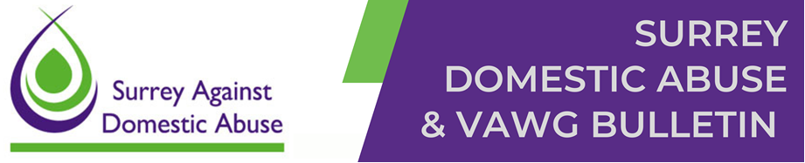

16 Days of Activism – ESDAS Events
As part of the 16 Days of Activism Against Gender-Based Violence, East Surrey Domestic Abuse Service invites you to four inspiring events – each designed to raise awareness, build resilience, and strengthen our communities. See attached flyers for further information and how to book – booking essential!
- Brave Conversations – Around Masculinity: Thursday 27 November, 7.30pm to 9.00pm, Reigate Cricket Club. (An honest, uplifting evening for men and allies exploring healthy masculinity and how we can all help end violence against women and girls)
- Empower Her – An Event for Women and Girls: Sunday 30 November, 2.00pm to 5.00pm, Nutfield Priory Hotel.(Celebrate strength and self-worth with inspiring speakers, creative workshops, and uplifting performances).
- Business Breakfast – Safe at Work: Monday 1 December, 8:45am to 10am, Reigate Town Hall. (Discover how employers can support staff affected by domestic abuse, with insights from survivor and advocate Fiona Bowman).
- Candlelit Walk of Remembrance: Tuesday 9 December, 4:30pm to 6pm, Redhill, The Belfry to Memorial Park. (Join us in a moving walk to honour lives affected by domestic abuse and remember those we’ve lost. A tree of hope will be planted, followed by reflection and warm drinks at Florrie’s Café).
Long-Overdue Legal Reforms Bring Hope and Protection for DA Survivors
Domestic abuse professionals across the UK are welcoming a trio of transformative legal reforms that promise to reshape the landscape of family justice and survivor protection. These changes - long overdue and hard-won through years of tireless campaigning - represent a seismic shift in how the legal system prioritises the safety, dignity, and rights of survivors and their children.
Ending the Presumption of Parental Involvement
In a historic move, the government has announced the repeal of the presumption that children benefit from contact with both parents, even in cases involving domestic abuse. This principle, embedded in the Children Act 1989, has long been criticised for enabling unsafe contact arrangements and perpetuating harm. The change follows the tireless advocacy of survivors like Claire Throssell, whose sons were tragically killed by their abusive father during court-ordered contact. The repeal sends a clear message: child safety must come before parental rights. Find out more: Government action to protect children from abusive parents - GOV.UK
Automatic Removal of Parental Rights for Sexual Offenders
Under new amendments to the Victims and Courts Bill, parents convicted of serious sexual offences against any child - or rape resulting in the birth of a child - will automatically lose parental responsibility. This reform ends the distressing reality where survivors were forced to co-parent with their abusers or seek court orders to restrict contact. It is a powerful affirmation that the rights of survivors and children must take precedence over those of convicted offenders. Find out more: Thousands of children protected from abuse under victim reforms - GOV.UK
Scrapping Fees for Protective Orders
Starting next month, survivors will no longer have to pay the £318 fee to remove their personal details from public records via a Person at Risk of Violence (PARV) Order. This change eliminates a financial barrier that has prevented many from seeking safety, especially those facing economic abuse. It’s a simple yet profound step toward ensuring survivors can protect themselves without added financial hardship. Find out more: Better protection for victims at risk of violence as fee scrapped - GOV.UK
Looking Ahead: A Review of Stalking Laws
In addition to these reforms, an urgent independent review of stalking legislation has been launched, led by Richard Wright KC. The review will assess whether current laws adequately protect victims and address emerging forms of stalking, including digital abuse. This initiative reflects growing recognition of the devastating impact stalking has on survivors and the need for a more robust legal response. Find out more: Expert KC to lead urgent independent review of stalking laws - GOV.UK
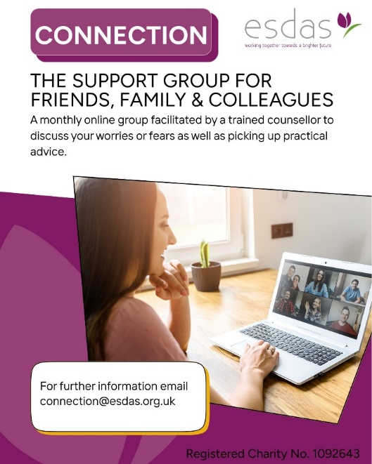
New online support group for friends and family members

There is a new initiative from East Surrey Domestic Abuse Services (ESDAS) - a dedicated Friends & Family Support Group, designed specifically for those who are supporting someone affected by domestic abuse.
Whether it’s a friend, family member, colleague, or neighbour, supporting someone through abuse can be emotionally complex and isolating. This online support group, led by a trained counsellor, offers a compassionate space to connect, learn, and feel supported.
What the group offers:
A safe, confidential space to share and explore your concerns; Practical guidance on how to support someone safely and sensitively; Advice on how to care for your own wellbeing while supporting others.
To join the group or find out more, email: connection@esdas.org.uk
Training opportunities:
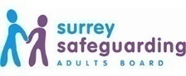
Surrey Safeguarding Adults Board Training Programme
The SSAB are pleased to advise that a new webinar session has been released.
New Session:
- In Safe hands? Domestic Abuse Survivors' Experience of General Practice
On Wednesday 19th November the SSAB will be holding a webinar session on Domestic Abuse survivors' experience of General Practice. The Session will start at 12:30. For more information and to book your place
Please also note that the recording from session one of the Surrey Suicide Prevention Awareness – Learning from SARs and DARDRs has now been published and is available to view along with the presentation slides. The date for session 2 has now been released. For more information and how to register your place, or to view the slides and recording please visit the SSAB Webinar page - https://www.surreysab.org.uk/training/learning-webinars/
All of the SSAB webinars can be accessed here
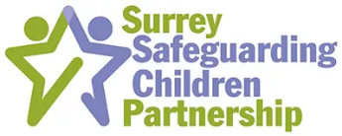
Surrey Safeguarding Children Partnership - Adolescent Safeguarding Training
The SSCP are pleased to announce the launch of a new training programme aimed at supporting frontline professionals in identifying children's needs, providing assistance, and ensuring their protection.
This training is being led by experts in social work, policing, mental health, lived experience, youth justice, and community safeguarding, and represents a significant shift in our approach to working with adolescents, their families, and communities as partners.
You can find more information and book your place for upcoming training events on our website Training - Surrey Safeguarding Children Partnership
Surrey Wide ICBs Safeguarding Team Primary Care Level 3 Webinars
Webinars can be downloaded from https://www.surreytraininghub.co.uk/Webinars/category/safeguarding-1
please email: syheartlandsicb.surrey.safeguarding@nhs.net for the password.
- Accelerated Record Access  - Catch 22 - Surrey Young People's Substance Misuse  - Clinical Record Keeping in Domestic Abuse  - County Lines & Child Criminal Exploitation  - Dental Neglect & Vulnerabilities  - Health needs of Looked after Children including unaccompanied asylum-seeking children  - High risk Domestic Abuse & MARAC processes in Surrey  - Introductory Level 3 training for staff new to Surrey as well as GP trainees  - Learning from case reviews | - Learning from 2023 GP Safeguarding Assurance Audit  - Learning from Surrey Domestic Abuse related deaths June 2024  - LeDeR learning from the lives & deaths: Reviews of people with learning disabilities  - Level 3 Safeguarding children & adults update for General Practice: September 2023, Session 1  - Level 3 Safeguarding children & adults update for General Practice: March 2024, Session 2  - Safeguarding Supervision  - Shooting Star Children’s Hospice  - RCGP Safeguarding Standards and Toolkit Webinar
Professional Curiosity Work & Training
Re-envisaging Professional Curiosity & Challenge - Surrey Safeguarding Children Partnership (surreyscp.org.uk)
Surrey Children’s Academy - Safeguarding courses, e-learning, events, and resources - Book now!
The sessions below can be booked via MyLearning. Are you having trouble using MyLearning or encouraging your team to use it? Register for one of our drop-in sessions here or contact the academy to discuss booking a personalised session for your team.

What’s on offer?
We have a huge multi-agency safeguarding offering open to you over the coming months – Some of these sessions are only running once this financial year (highlighted in in bold) take a look below:
Date | Time | Title
10 November | 10am-11am | ACT Introduction Workshop: Understanding Harmful Sexual Behaviour (Virtual)
12 November | 10am-1pm | Safeguarding Children with Disabilities: Focus on Children with Autism (Freemantles School)
21 November | 9.45am-4pm | Advanced Safeguarding in Surrey: Child Protection Processes and Children in Care (Woodhatch Place)
24 November | 10am-1pm | Ritual Abuse (Virtual)
26 November | 9.15am-12.15pm | Early Help Assessment and Team Around the Family Workshop (Virtual)
26 November | 10am-12pm | Time for Kids: Induction Session (Virtual)
26 November | 10am-4pm | An Introduction to Harmful Sexual Behaviour: Young Children and Adolescents (Quadrant Annexe)
2 & 3 December | 9am – 4pm (2pm day 2) | Graded Care Profile 2 (NSPCC GCP2) Workshop (Virtual)
10 December | 9.45am-1pm | Neglect: Partnership Workshop (Virtual)
16 December | 9.45am-4pm | Advanced Safeguarding in Surrey: Child Protection Processes and Children in Care (Virtual)
Finally, a new Complex Needs Learning Pathway has been launched to support you in your work with our most vulnerable children and young people. The below email provides the context around the pathway in addition to links to the resources available, including an introductory webinar, a suite of e-learning, toolkits, and guides.
Surrey's domestic abuse (DA) training is free to attend for professionals and volunteers working to prevent or respond to DA in Surrey. The training is a great opportunity to build confidence in recognising and responding to DA. It’s relevant to anyone who may come across domestic abuse in their work, and it can really help make a positive difference for those affected, everyone is welcome.
How to book:
To review course objectives, find available dates, and book your place, please use the links provided below. To book for FREE you must enter the registration code for Surrey Domestic Abuse Training - SURREYDA. Courses will be delivered online via Microsoft Teams, except for the Anti-Victim Blaming training which is delivered in person. PLEASE NOTE: If your chosen course is fully booked, please join the waiting list and you will be notified as soon as new dates become available.
Courses available to book now:
The following courses are available on various dates up to and including December 2025.

- Anti Victim Blaming (in person)
- Domestic Abuse is Everybody's Business (Awareness L1)
- Domestic Abuse Level 2
- Domestic Abuse Level 3 Working with those who cause/at risk of causing DA
- Domestic Abuse Level 3 Working with Victims and Survivors
- Child to Parent Abuse
- Domestic Abuse and the Effects on Children
- Dual Allegations
- Housing and Homelessness
- LGBTQIA+
- Male Victims
- MARAC (Multi-Agency Risk Assessment Conference)
- Mental Health and Suicide Prevention
- Safety Planning
- Stalking and Harassment
- Young People and Abusive Relationships

These training sessions provide essential information on key topics concisely. Each session is designed to be easy to follow, making them ideal for professionals and volunteers who may not have time to attend a full-day course. Completing Domestic Abuse Level 1 is recommended before joining further courses. This will give you a solid understanding of the wider context of domestic abuse, helping you get the most out of the other sessions.
Seen harassment in public? Not sure what to do?

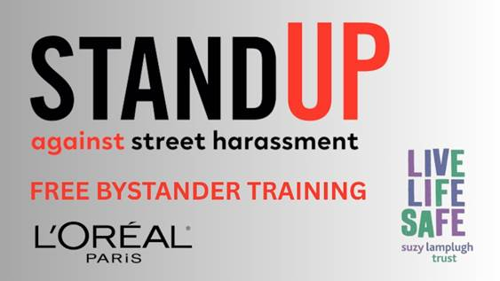
You can make a difference - safely and confidently. Free online bystander training is now available for anyone who lives, works or socialises in Surrey, delivered by the Suzy Lamplugh Foundation and supported by L’Oréal Paris.

- Learn how to spot harassment
- Know how to respond safely
- Help make Surrey’s public spaces safer for everyone

It’s quick. It’s practical. It’s free. Sign up today: Stand Up Against Street Harassment | Healthy Surrey

Contact Details for the Surrey Wide ICBs Safeguarding Children, Adults, Looked After Children and Child Death Review Professionals:
To contact any of the team please email: syheartlandsicb.surrey.safeguarding@nhs.net
Audrey Scott-Ryan  Associate Director Safeguarding | Lisa Parry  Safeguarding Team Business Manager | Caroline Holmes  Deputy Safeguarding Team Business Manager
Tania Steeples  Safeguarding Team Business Support Officer | Linda Cunningham / Rachael Redwood / India Sholeh  Designated Nurse Looked after Children | Dr Sharon Kefford  Designated Doctor for Looked after Children
Tara Hyde  Looked After Children and Safeguarding Children Business Support | Dr Kate Brocklesby  Designated Doctor Safeguarding Children | Tracey Bogalski & Eileen White  Designated Nurse for Safeguarding Children
Julie Wadham  Safeguarding Transition Advisor | Dr Tara Jones  Designated GP Safeguarding Adults and Children | Helen Milton & Rebecca Eells  Designated Nurse Safeguarding Adults
Dr Jamie Carter  Designated Doctor for Child Death Review | Noreen Gurner-Smith  Designated Nurse for Child Death Reviews | Suzanne Huddy  Named Nurse for Child Death Review
Natalie Price / Anna Chai / Clare Kemp  Specialist Nurse Child Death Review | Emily Welch  Child Death Review Co-ordinator | Anna Miles  Deputy Child Death Review Co-ordinator
Nicola Mundy
Child Wellbeing Professional and Lead for Learning from Child Deaths

