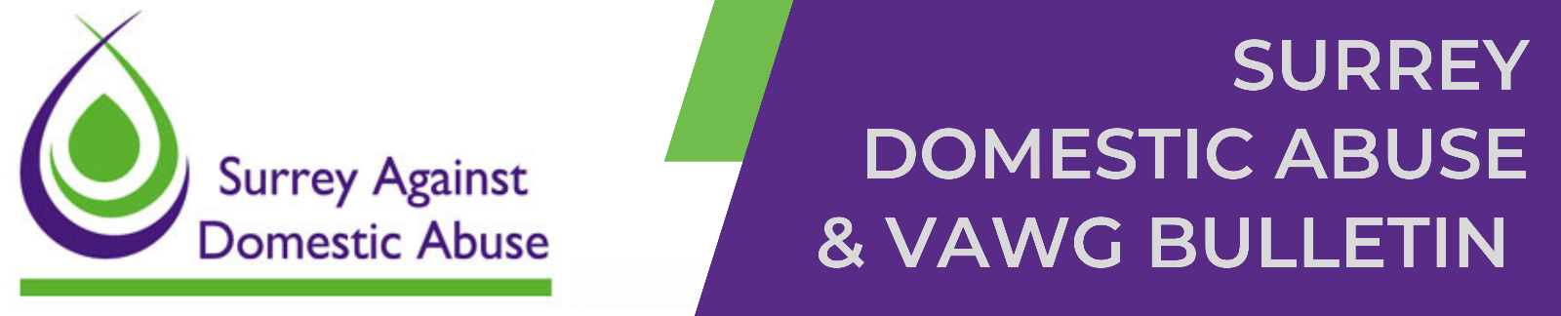

Surrey's domestic abuse (DA) training is free to attend for professionals and volunteers working to prevent or respond to DA in Surrey. The training is a great opportunity to build confidence in recognising and responding to DA. It’s relevant to anyone who may come across domestic abuse in their work, and it can really help us make a positive difference for those affected, everyone is welcome.

How to book:

To review course objectives, find available dates, and book your place, please use the links provided below. To book for FREE you must enter the registration code for Surrey Domestic Abuse Training - SURREYDA. Courses will be delivered online via Microsoft Teams, except for the Anti-Victim Blaming training which is delivered in person. PLEASE NOTE: If your chosen course is fully booked, please join the waiting list and you will be notified as soon as new dates become available.

Courses available to book now:

The following courses are available on various dates up to and including March 2026.

- Anti Victim Blaming (in person)
- Domestic Abuse is Everybody's Business (Awareness L1)
- Domestic Abuse for Professionals (Level 2)
- Advanced - Domestic Abuse for Professionals (L3 Working with Victims and Survivors)
- Elder Domestic Abuse - Microteach
- Financial Abuse
- Harmful Practices – FGM/HBA/FM/Cultural competency - Microteach
- Learning from Serious Case and Domestic Abuse Related Death Reviews and VAWG - Microteach
- Risk Identification and Assessments (DASH) - Microteach
- The Domestic Abuse Legal Framework - Microteach
- Understanding Child Abuse and Exploitation within the context of Domestic Abuse
- Working with People Convicted of or at Risk of Causing Domestic Abuse (Level 3)

Please share this email among your networks. If you have been sent this by a colleague and would like to join our mailing list to receive DA/VAWG bulletins directly, please click here to register.
Useful Links:

- Surrey Against Domestic Abuse - Healthy Surrey
- Domestic Abuse Training | Healthy Surrey
- Anti Victim Blaming Guidance | Healthy Surrey
- Surrey Gold Standard Coercive and Controlling Behaviour Framework | Healthy Surrey

UNSUBSCRIBE: if you’d like to say goodbye and don’t wish to receive this bulletin and other communications from us please send an email and we’ll remove your details from the mailing list

