

Surrey's domestic abuse (DA) training is free to attend for professionals and volunteers working to prevent or respond to DA in Surrey. The training is a great opportunity to build confidence in recognising and responding to DA. It’s relevant to anyone who may come across domestic abuse in their work, and it can really help us make a positive difference for those affected, everyone is welcome.

How to book:

To review course objectives, find available dates, and book your place, please use the links provided below. To book for FREE you must enter the registration code for Surrey Domestic Abuse Training - SURREYDA. Courses will be delivered online via Microsoft Teams, except for the Anti-Victim Blaming training which is delivered in person. PLEASE NOTE: If your chosen course is fully booked, please join the waiting list and you will be notified as soon as new dates become available.

Courses available to book now:

The following courses are available on various dates up to and including December 2025.

- Anti Victim Blaming (in person)
- Domestic Abuse is Everybody's Business (Awareness L1)
- Domestic Abuse Level 2
- Domestic Abuse Level 3 Working with those who cause/at risk of causing DA
- Domestic Abuse Level 3 Working with Victims and Survivors
- Child to Parent Abuse
- Domestic Abuse and the Effects on Children
- Dual Allegations
- Housing and Homelessness
- LGBTQIA+
- Male Victims
- MARAC (Multi-Agency Risk Assessment Conference)
- Mental Health and Suicide Prevention
- Safety Planning
- Stalking and Harassment
- Young People and Abusive Relationships

These training sessions provide essential information on key topics concisely. Each session is designed to be easy to follow, making them ideal for professionals and volunteers who may not have time to attend a full-day course. We recommend completing Domestic Abuse Level 1 before joining further courses. This will give you a solid understanding of the wider context of domestic abuse, helping you get the most out of the other sessions.

Seen harassment in public? Not sure what to do?

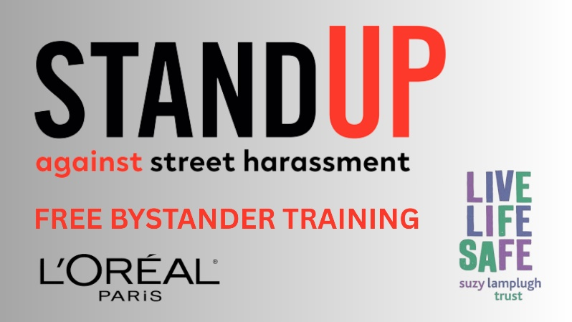
You can make a difference - safely and confidently. Free online bystander training is now available for anyone who lives, works or
socialises in Surrey, delivered by the Suzy Lamplugh Foundation and supported by L’Oréal Paris.

- Learn how to spot harassment
- Know how to respond safely
- Help make Surrey’s public spaces safer for everyone

It’s quick. It’s practical. It’s free. Sign up today: Stand Up Against Street Harassment | Healthy Surrey

Please share this email among your networks. If you have been sent this by a colleague and would like to join our mailing list to receive DA/VAWG bulletins directly, please click here to register.

Useful Links:

- Surrey Against Domestic Abuse - Healthy Surrey
- Domestic Abuse Training | Healthy Surrey
- Anti Victim Blaming Guidance | Healthy Surrey
- Surrey Gold Standard Coercive and Controlling Behaviour Framework | Healthy Surrey

UNSUBSCRIBE: if you’d like to say goodbye and don’t wish to receive this bulletin and other communications from us please send an email and we’ll remove your details from the mailing list.

